# Assignment 14: Individual Research

# 5G Network and Mobile Large-Scale Analytics

Puja Kawale, Software Engineering, San Jose State University, Santa Clara, USA., Dt.11/25/2018,

SJSU ID: 012506156, puja.kawale@sjsu.edu

**Introduction**: Telecommunication and networking have been and can be one in all the gist engineering in serving to the development of humanity and technology itself. If it wasn’t for it for these channels of 3 senses of communication and knowledge transmitting, we'd most likely still be in geological era wherever technology isn’t as advanced as these days.1G brought us the very first cellular phone speech sound, 2G allowed us to text for the first time, 3G brought us online and 4G delivered the speeds that we tend to relish in today’s date. **What is 5G?** This brand new, 5th generation wireless technology is still in developing state and would be out in 2020.

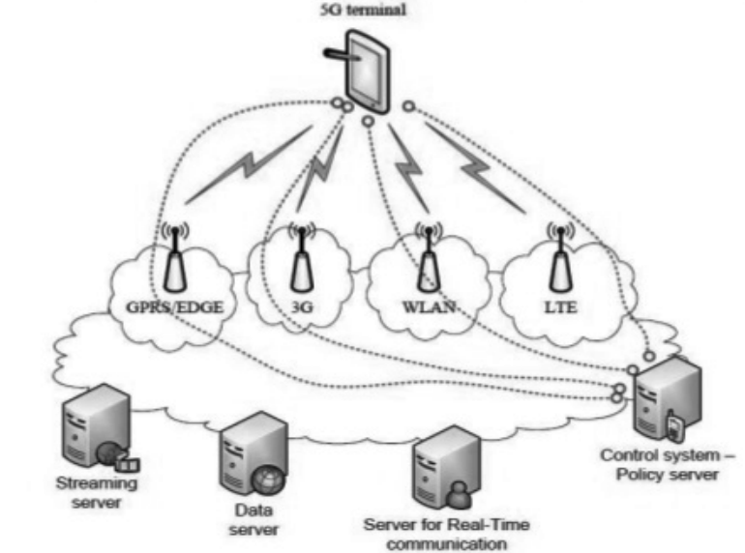

Figure: 5G Architecture

Source: http://pubs.sciepub.com/ajss/2/4/5/

User now have high expectations from the service providers with respect to the service quality, this is leading to the complexities with traffic, latency and high usages. Therefore, the main objective of service provider is now quality and user

Experience. Along with this the adoption of M2M services would be encouraged to facilitate high network capacity to cater large connections. As we all know, that server usage workloads are increasing and network bandwidth is also in high demand. There is clear cut need of optimization of capacity.

In all 1.5 billion browser pages are accessible, 650,000 mobile applications are being accessed, and 10,500 radio platforms are prevailing.

5G innovation has changed the implies to utilize cell phones within exceptionally exorbitant transfer speed. Client never experienced ever before such a inflated esteem innovation. These days versatile users have become smarter of the portable device technology. The 5G advances incorporate all sort of progressed features which makes 5G innovation most capable and demanding in close future.

The huge range of inventive innovation being built into upcoming devices is staggering. 5G innovations which are on hand held phone advertising more control and highlights than at least 1000 lunar modules. A client can moreover snare their 5G technology cell phone with their Tablet to urge broadband web access. 5G innovation counting camera, MP3 recording, video player, large phone memory, dialing speed, sound player and much more you never envision. For children shaking fun Bluetooth technology and Pico nets has ended up in advertise.

This complete power stuffed package would be infused with high speed, low power consumption, increased capacity, latency like never before, awesome resolution and high data privacy and security. There would be more than mentioned and anticipated for sure!!

Let us dive deeper in the features and capabilities of every generation with respect to its characteristics.

Differentiating every generation of telecommunication and data network -

1G: First generation telecommunication network was a basic service to make voice calls. Below are the specifications of the same -

* Deployment: 1970 – 1980
* Data Rate: 2kbps
* Technology: Analog cellular technology
* Service: Analog voice service, No data service
* Multiplexing switching: FDMA
* Core Network: PSTN
* Standards: MTS, AMTS, IMTS
* Web Standards: None
* Handoff: Horizontal
* Drawbacks: Low capacity, poor voice links, less secure, Unreliable handoff

2G: Second generation telecommunication network was a voice calls with extended SMS service. Below are the specifications of the same –

* Deployment: 1990 – 2001
* Data Rate: 14.4 – 64 kbps
* Technology: Digital cellular technology: digital narrow band, circuit data, packet data
* Service: Digital voice with high clarity, SMS, MMS, Higher capacity packet data
* Multiplexing switching: TDMA, CDMA
* Core Network: PSTN
* Standards: 2G_GMS, 2.5_GPRS, 2.75_EDGE
* Web Standards: www
* Handoff: Horizontal
* Drawbacks: Digital signals were reliant on location and proximity, required strong digital signals to help mobile phones.

3G: Third generation telecommunication network was a voice call, messaging and online capabilities. Specifications of the same –

* Deployment: 2001 – 2010
* Data Rate: 2 mbps
* Technology: Digital broadband packet data, CDMA 2000, EVDO, UMTS, EDGE.
* Service: Enhanced audio-video streaming, video conferencing support, Web browsing at higher speed, IPTV support.
* Multiplexing switching: CDMA
* Core Network: packet network
* Standards: IMT-2000, 3.5G-HSDPA, 3.75G-HSUPA
* Web Standards: www (IPv4)
* Handoff: Horizontal and vertical

Drawbacks: Need to accommodate higher network capacity.

4G: Fourth generation telecommunication network was developed to pace with the increased data speed and access. It provided HD streaming. Below are the specifications of the same -

* Deployment: 2011
* Data Rate: 200mbps – 1GBPS
* Technology: Digital broadband packet data, WiMax LTE, Wifi
* Service: Enhanced Audio-Video streaming, IP telephony, HD mobile TV
* Multiplexing switching: CDMA
* Core Network: Internet
* Standards: Single unified standard LTE, WiMax
* Web Standards: www (IPv4)
* Handoff: Horizontal and Vertical
* Drawbacks: Deployment

5G: First generation telecommunication network was developed to pace with the increased data speed and access. It provided HD streaming. Below are the specifications of the same -

* Deployment: 2015 to 2020 onwards
* Data Rate: > 1GBPS
* Technology: wwww Unified IP seamless, combination of broadbands LAN, PAN, MAN, WLAN.
* Service: Dynamic information access, Wearable device with AI, capabilities
* Multiplexing switching: CDMA
* Core Network: Internet
* Standards: Single unified standard
* Web Standards: wwww (IPv6)
* Handoff: Horizontal and Vertical
* Drawbacks: Yet to deployed, hence unknown

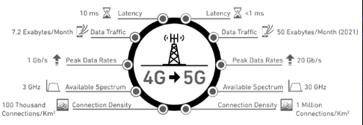

Figure: 4G Vs 5G

**Key performance indicator** like Call drop rates and response can be measures by below formulas –

Voice Call Drop: Chances of a phone call to end or hang-up without any of the users’ intension to do so.

**Drop Rate** [%] = (Number of Calls terminated without intension / Number of call made) * 100.

In case of 4G rollout where signals are lost, calls are being dropped and download speeds can be none specially in remote areas with supposedly full 4G coverage is assumed. 5G will be dominating and would help to eliminate these problems.

**Download** **time**:

|  |  |
| --- | --- |
| 4G Network | 100Mbps |
| 5G Network | 1-10Gbps or higher |

**Latency**:

|  |  |
| --- | --- |
| 4G Network | 50ms (actual)* |
| 5G Network | 1ms (theoretical) |

It’s a secure wagered that 5G will be focusing at data exchange speeds within the gigabits per second run. 1Gbps is equivalent to billions of bits per second, building on from Mbps (millions of bits per moment) in 4G and Kbps (thousands of bits per moment). 1Gbps is hence proportionate to 1,000Mbps, and 5G will be the primary time such lightning quick information downloads will be conceivable on a versatile gadget.

**5G data sources for mobile**: 5G behaves as a medium between several source and targetas it transports the data faster with reduced latency. 5G gets raw data from various streams from original source to mirror sources. This data is collected from online sources like social media or from surveys that take place offline. Several IOT deices would also act as a source of data to 5G. Other devices, home appliances, Alexa devices, smart watches, FastTrack electronic toll collection, Program logic controllers, Human machine interfaces, mobile device sensors - humidity sensor, temperature sensor, proximity sensor, accelerometer, magnetometer, GPS, location sensor, etc. All this data collected would be transported to intended target systems like data centers, end users, applications and machine learning models.

**Streaming**: Capacity will moreover be imperative for long-term of video streaming. By 2030, it is predicted that 76 per cent of its information activity will be utilized for gushing videos. And the lion's share of that will be 4K Ultra HD or indeed 8K resolutions. Verizon and other web suppliers are aiming to distribute 5G web this year. It will for sure alter user experience of TV and web in homes. Instead of outdates cable mesh over the home, user would get an evolved service and a membership to a streaming videos and channels networks. 5G would enable flawless streaming to accommodate 4K movies and gaming together.

As per CNBC news report, Verizon would hand out an Apple TV 4K and a wireless modem. Since Verizon isn't aiming to install a standard cable line to homes, but to incorporate a membership for YouTube TV, YouTube's gushing benefit that will give get to TV channels. YouTube TV regularly costs $40 per month, but Verizon's bargain is likely only a limited-time offer. You'll still have a modem at domestic, but it'll interface to Verizon's wireless 5G flag and after that serve as a domestic Wi-Fi switch, total with standard Ethernet ports. This is often how gadgets just like the Apple TV 4K, your smartphone, computer and other web contraptions will interface to Verizon's 5G remote arrange. PCMag had a look at one of the switches Verizon said it was at first considering in 2017. This implies you won't got to run a cable all through your domestic to each TV, since you won't be utilizing cable boxes to induce your TV substance. No more penetrating through dividers. No more holding up for the cable fellow. Fair plug in your Verizon modem and get online. Ultimately and vitally, it's vague how much all of this will take a toll. Verizon's beginning 5G offer will deliver you a free Apple TV 4K ($179) and a membership to YouTube TV ($40 per month). It's hazy and unclear as to how much the 5G benefit will bill you each month, and there will likely be a month to month hardware charge incurred.

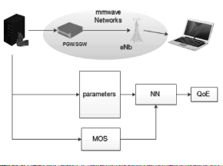

Figure: Video Streaming on 5G

5G is well designed and developed for streaming administrations to thousands of devices in one region, where 4G systems would rapidly end up blocked or choked. With this in intellect, Japan is executing 5G in stadiums for the Olympics. 5G’s expanded substances are set to permit onlookers to see numerous points and points of view of matches and occasions on exact live time through their claim end points, and get live interpretations of content and sound on live time. 5G permits this to set high standards for stadium occasions.

5G has already proved the offering of 1 Gbps for clients. These ten times increment in data streaming makes spilling tremendous sums of data completely practical with 5G technology. A data transfer of   of 40 to 100 Mbps would practically be possible with advent of 5G. Where streaming already set the standards for video and music, 5G can make video game transferring a fact. As with virtual reality and Ultra HD, playing advanced video games through network stream systems has, until 5G, been hampered by the tremendous measure of video information required, and by issues of inactivity: a button ought to be pushed and the stream has to react promptly, all whereas colossal volumes of HD video are being spilled each moment. Video diversion designers are as of now declaring streaming systems, and it’s the data transfer rates of 5G that are set to create these plans reality for users.

**5G data cost**: Considering south Korea – a nation of 51 million individuals with great fiber foundation that’s broadly accessible to back the spine of 5G administrations, the fetched of 5G is set to surpass $8 Billion in capital speculations for a single benefit supplier. This prohibits over $870 million for 100 MHz in 3.5 GHz that’s planned for sell off sooner.

Verizon confirms, clients will get it without charge for the primary three months. After that early on period, current Verizon Remote clients with a qualifying smartphone arrange will pay $50 per month for the benefit, whereas non-Verizon Remote clients will pay $70 per month, there would be no yearly contract or extra equipment costs. With the advent of 5G, making 3D facetime conversations on apple phone would generate truly shocking wireless bill. On todays date, 4G mobiles charges 10X higher charge than 2G or 3G gadgets, [according to Cisco](http://www.cisco.com/c/en/us/solutions/collateral/service-provider/visual-networking-index-vni/white_paper_c11-520862.html). Mobile phone bills are getting bigger and bigger when we have a deeper though on history. In 2013, the normal phone would barely cost 76$/month. As per the CNN, to the end of year 2019, Cisco estimates that, smartphone information activity to and cell towers and from the cell towers, roundtrip (not offloaded to Wi-Fi) will develop by 57%. So, in case data plans remain the same for a long time down the street, normal plan or charge might elevate from $43/month to $119/month. 5G might push us in a space of ultra-high definition video on mobile devices and a pile of mobile apps that are unfathomable nowadays. But users for sure need to pay their big fat hard money to require advantage of all that experience and speed. T mobile confirms that their upgraded scale permits the new T-Mobile to compete at lower costs with no end in sight. Capacity will rise and the data cost will fall! Similarly, may it be AT&T, Sprint, US Cellular, Verizon or T-Mobile every service provider would make most of the margin and charge high on 5G data plans and services.

**Large Scale mobile data analytics**: Analytics is all about collecting information and transforming it into valuable data which finally gives insights, and helps make predictions. These predictions are always fruitful for growing the business.

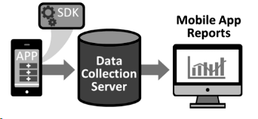

Figure: Large scale mobile analytics

Using the Mobile analytics, we can track user acquisition matrix, user engagement matrix, active users, average revenue per user, cost per install, crash report, loading data or time, network issues.

Large Scale data analytics are done with approaches like MapReduce, Hadoop and R as below diagram.

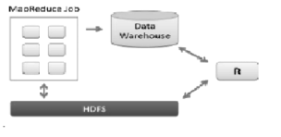

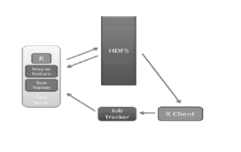

References:

Web links:

<http://www.science.smith.edu/dftwiki/images/6/6a/ComparisonOfApproachesToLargeScaleDataAnalysis.pdf>

<https://mse238blog.stanford.edu/2017/07/ssound/1g-2g-5g-the-evolution-of-the-gs/>

<https://ieeexplore.ieee.org/document/7823332?denied=>

<https://ieeexplore.ieee.org/document/8141874>

<http://pubs.sciepub.com/ajss/2/4/5/>

<https://www.forbes.com/sites/forbestechcouncil/2018/09/07/how-the-5g-revolution-will-drive-future-innovations-of-iot/#244196c8637e>

<https://www.techradar.com/news/the-perfect-stream-dream>

<https://ieeexplore.ieee.org/abstract/document/6498463>

<https://www.antenova.com/5g-hub/will-5g-transform-consumer-tech/>

<https://arxiv.org/pdf/1407.4335.pdf>

Books/Papers:

David Ott, Shilpa Talwar, Intel Labs, University Research Office, “Exploring Next Generation Wireless (5G): Transforming the user Experience”, 2013.

Suvarna Patil, Vipin Patil, Pallavi Bhat, “A Review on 5G T